# Desmognathus quadramaculatus – Black-bellied Salamander (aBESAx)

**Introduction/narrative**

Summarization of species’ range extent and habitat?

Summarization of GBIF filtering criteria – either overall process for all species and/or specific to the individual taxon for whom the evaluation write-up is focused.

**GBIF Records Download Summary and Filter Criteria**

|  |  |
| --- | --- |
| **Filter Criteria (+ in addition to criteria in row above)** | **Number of records** |
| Desmognathus quadramaculatus / Has Coordinates / US | 963178 |
| + Not fossils | 885572 |
| + has coordinate uncertainty | 626642 |
| + ‘species’ = GAP scientific name | 499417 |
| + 1991 - 2006 | 19841 |

**Map of species’ range and habitat**

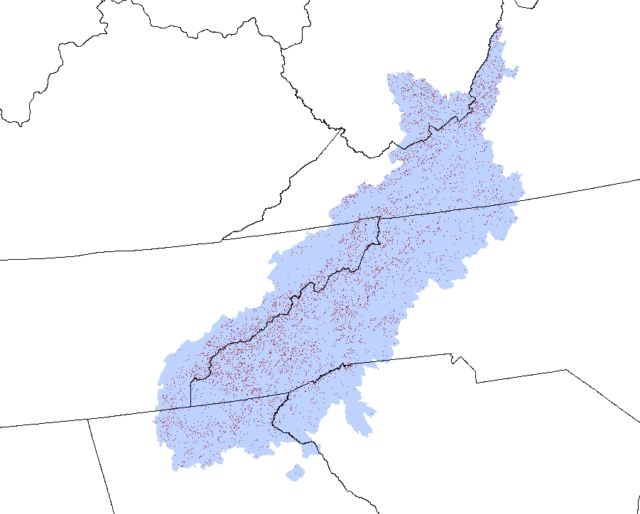

**Map of species’ range illustrating GBIF points, point buffers (from coordinate uncertainty and 10km) and minimum convex polygon surrounding GBIF points**

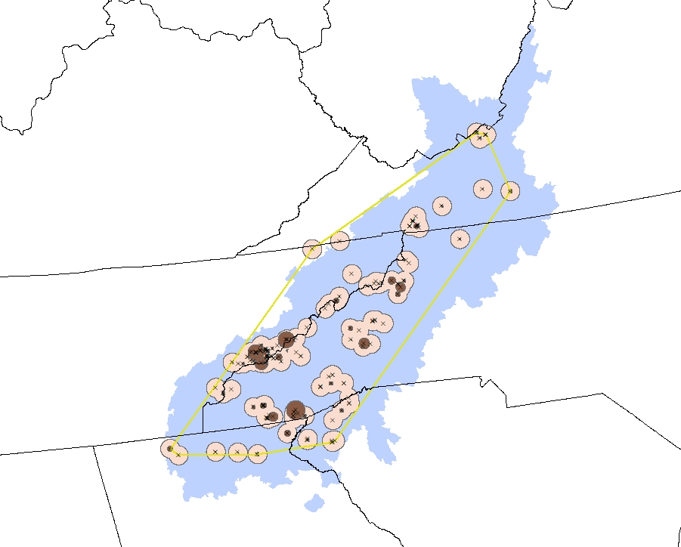

Extent of Occurrence (EOO) – A measure of a species’ range by the smallest polygon that encloses all occurrence points using a minimum convex polygon (MCP) method.

Area of Occupancy (AOO) – A measure of a species’ range comprising the summed area of tessellations/grids in which occurrence points are located. A modified version sums the area of buffers surrounding occurrence points buffered at varying or static distances.

**Evaluation measures summary**

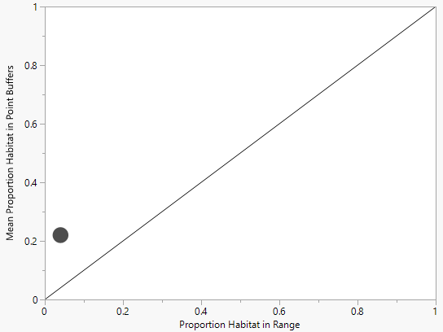

Proportion habitat in range vs. mean proportion habitat in point buffers for *Desmognathus quadramaculatus*. Points above the line indicate a species model ‘better than random’; points below indicate a model ‘worse than random’. Marker size is proportional to the number of records used in the assessment.

* Proportion habitat in GAP range = 0.040
* Mean proportion habitat in occurrence point buffers = 0.220
* Proportion EOO of GAP range (minimum convex polygon) = 0.599
* Proportion AOO of GAP range (occurrence points buffered using coordinate uncertainty) = 0.002
* Proportion AOO of GAP range (occurrence points buffered at 10km) = 0.216
* Number of occurrence points in GAP range = 172
* Number of occurrence points outside GAP range = 2